1. **Installation methods on Docker**

* From Docker Repository- package management
* From manual using DEB package
* Conventional script

1. **System Requirements**

* OS Version : Ubutunu 22.04LTS
* Platform : Orcale vm
* Ram: 2+GB
* CPU: 1 Core
* Storage ; 20 +GB

1. Virtual Machine Setup

* Open any broser and download oracle virtual box download
* C;ick on link and download the virtual box
* 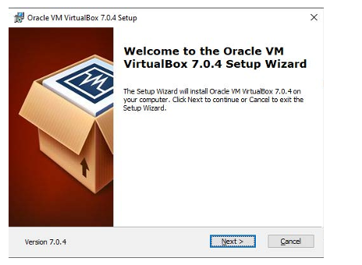
* 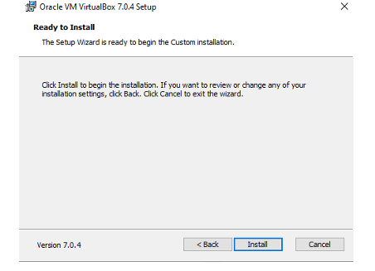
* Once installation is done , click on finish
* Search for oracle virtual box in windows and open it

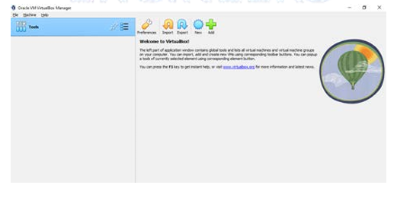

1. Prerequisite to create a virtual machine in Oracle virtual box

* Download the ISO image of Ubuntu Server 24.04.02 live server
* In Oracle virtual box click on new, displayed on top to fillinformation

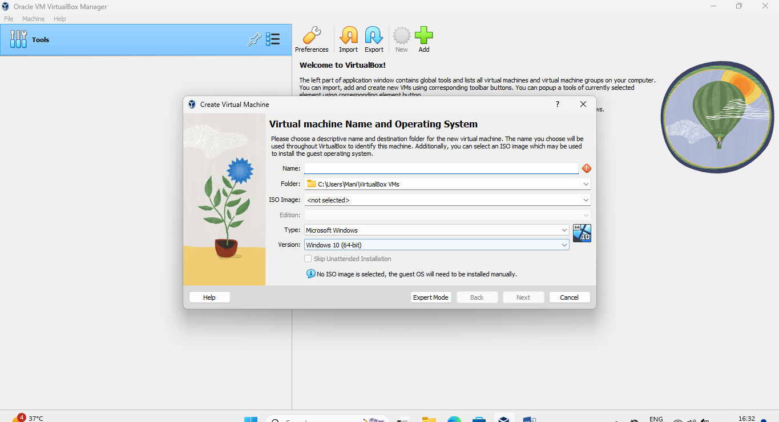

* Give Name of Virutal machine as-DockerEngine-Ubuntu2402,click on drop down and provide the iso which already downloaded and click Next
* Select username –testuser
* Password -*****
* Hostnae –Dockerserver
* Click next
* Enter memory-4 GB
* CPU-3 core
* 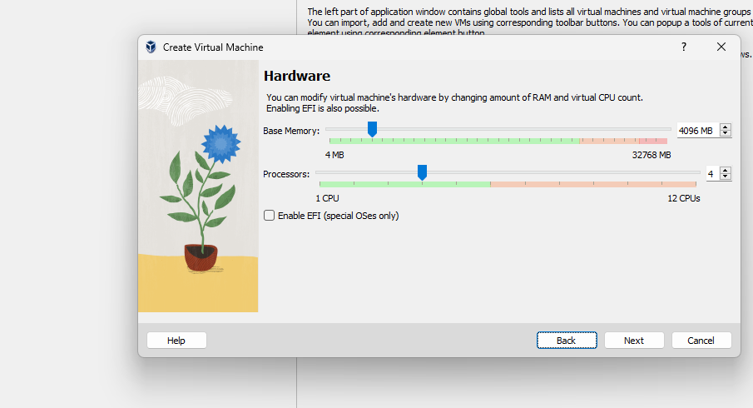
* Storage-100 GB
* 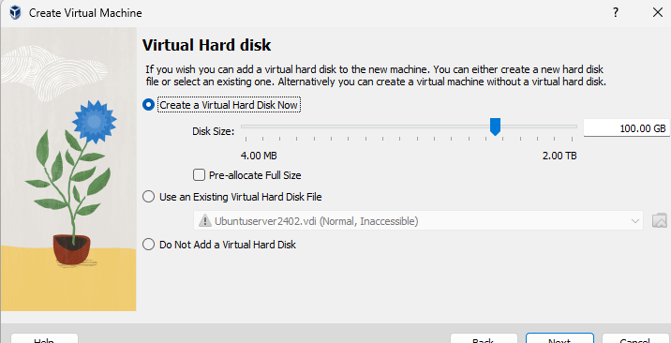
* Find the summary and click finish
* 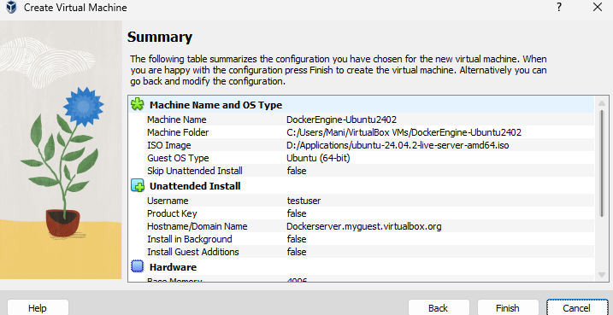
* Launch the server and set the langague as English
* C
* 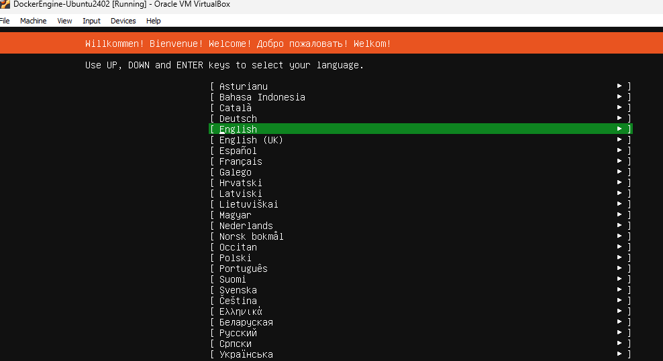
* Choose the Ubuntu server installation and click enter
* Next is network adapater for Ubuntu click next
* Next page is proxy server.. click done
* Next is disk partion click done
* Your name : User
* Your server name :dockerserver
* Pick a username: testuser
* Password: ***
* Enable the ssh and click continue

1. **Installation of Docker:**

**Pre-requisites**

|  |  |  |
| --- | --- | --- |
| Ubuntu | 64-bit linux installation | we have 24.04.02 |
|  | kernel version 3.10 higher | uname -r |
|  | apt update | to update the packages of machines server |
|  | apt install apt-transport-https | package manager-https based tranfser of files, data and information |
|  | curl | command line browser |
|  | ca-certificates | for system to check/validate the security certificates |
|  | software-properties-common | To add /allow execution of scripts |

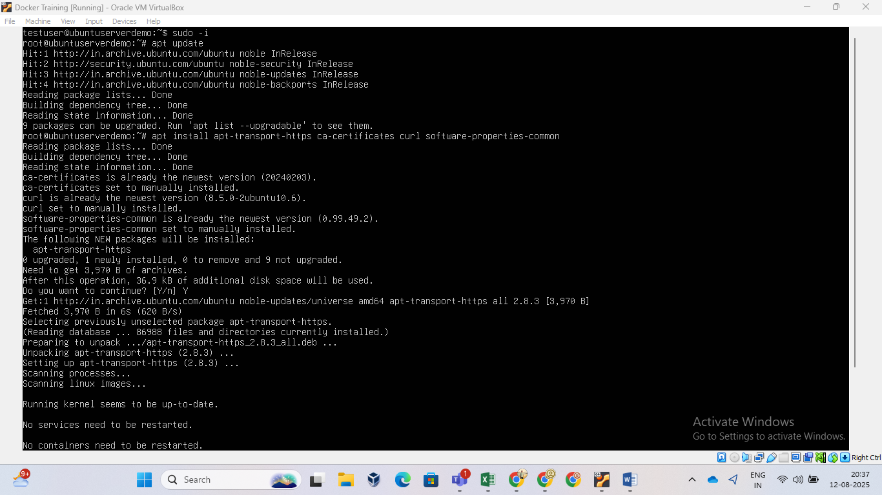

1. **Docker installation via apt repository**

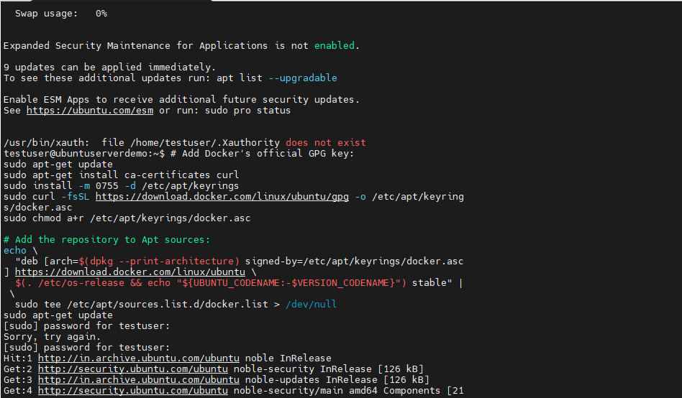

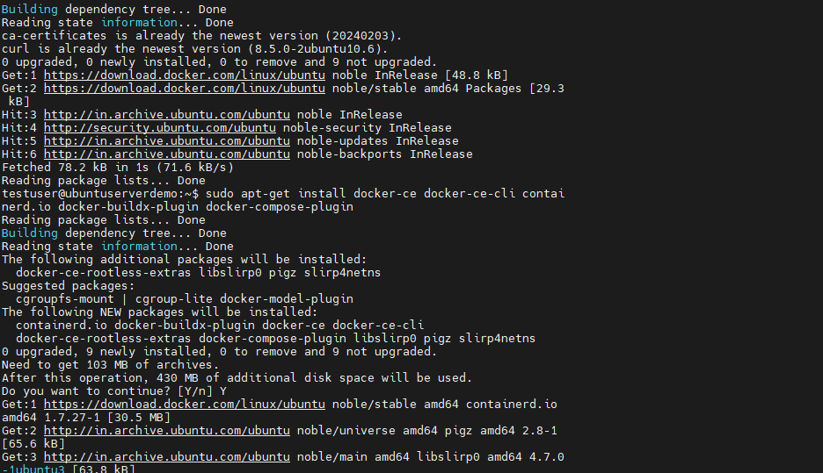

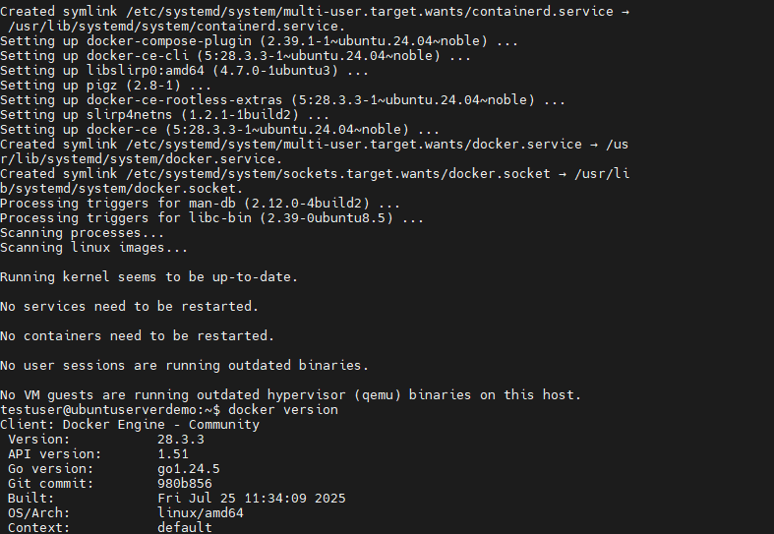

1. **To check the status of docker command used : systemctl status docker**

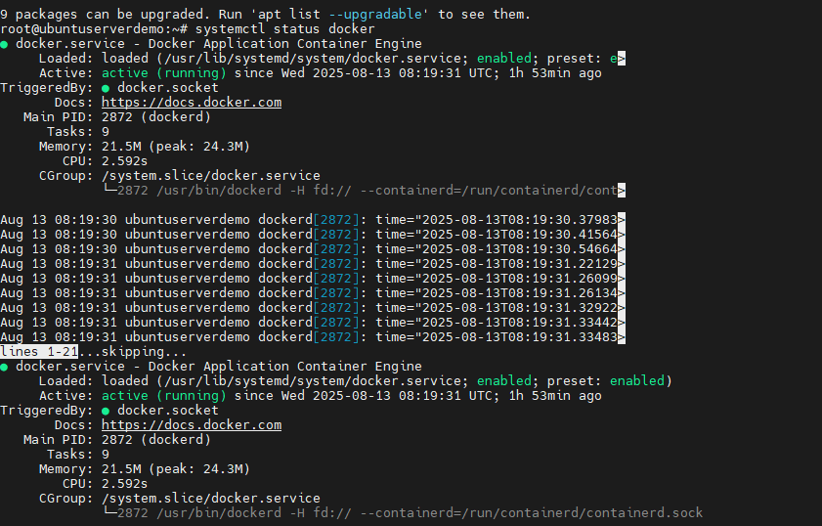

1. **To enable Docker command used: systemctl enable docker**

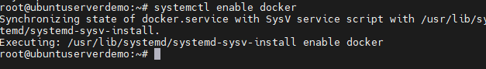

1. **To check docker version : docker –version or docker version**



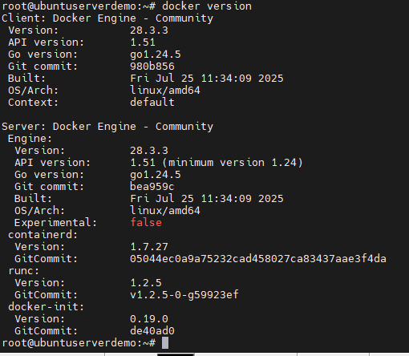

1. **To start the docker : systemctl start docker**

